IcedID Lab — Writeup
CyberDefenders | Threat Intel Category

Scenario
A cyber threat group was identified initiating widespread phishing campaigns to distribute further malicious payloads. The most frequently encountered payload was IcedID. Given a hash of an IcedID sample, the goal was to analyze it and monitor the activity of the associated advanced persistent threat (APT) group, using VirusTotal, malpedia, Recorded Future Triage Sandbox, and ANY.RUN.

Tools Used
VirusTotal, Recorded Future Triage Sandbox, ANY.RUN, malpedia

Q1 — What is the name of the file associated with the given hash?
Approach:
Paste the sample hash into VirusTotal's search bar, then open the Details tab and check the Names section. VirusTotal aggregates every filename the sample has ever been submitted under, since the same file can be seen in the wild under many different names.
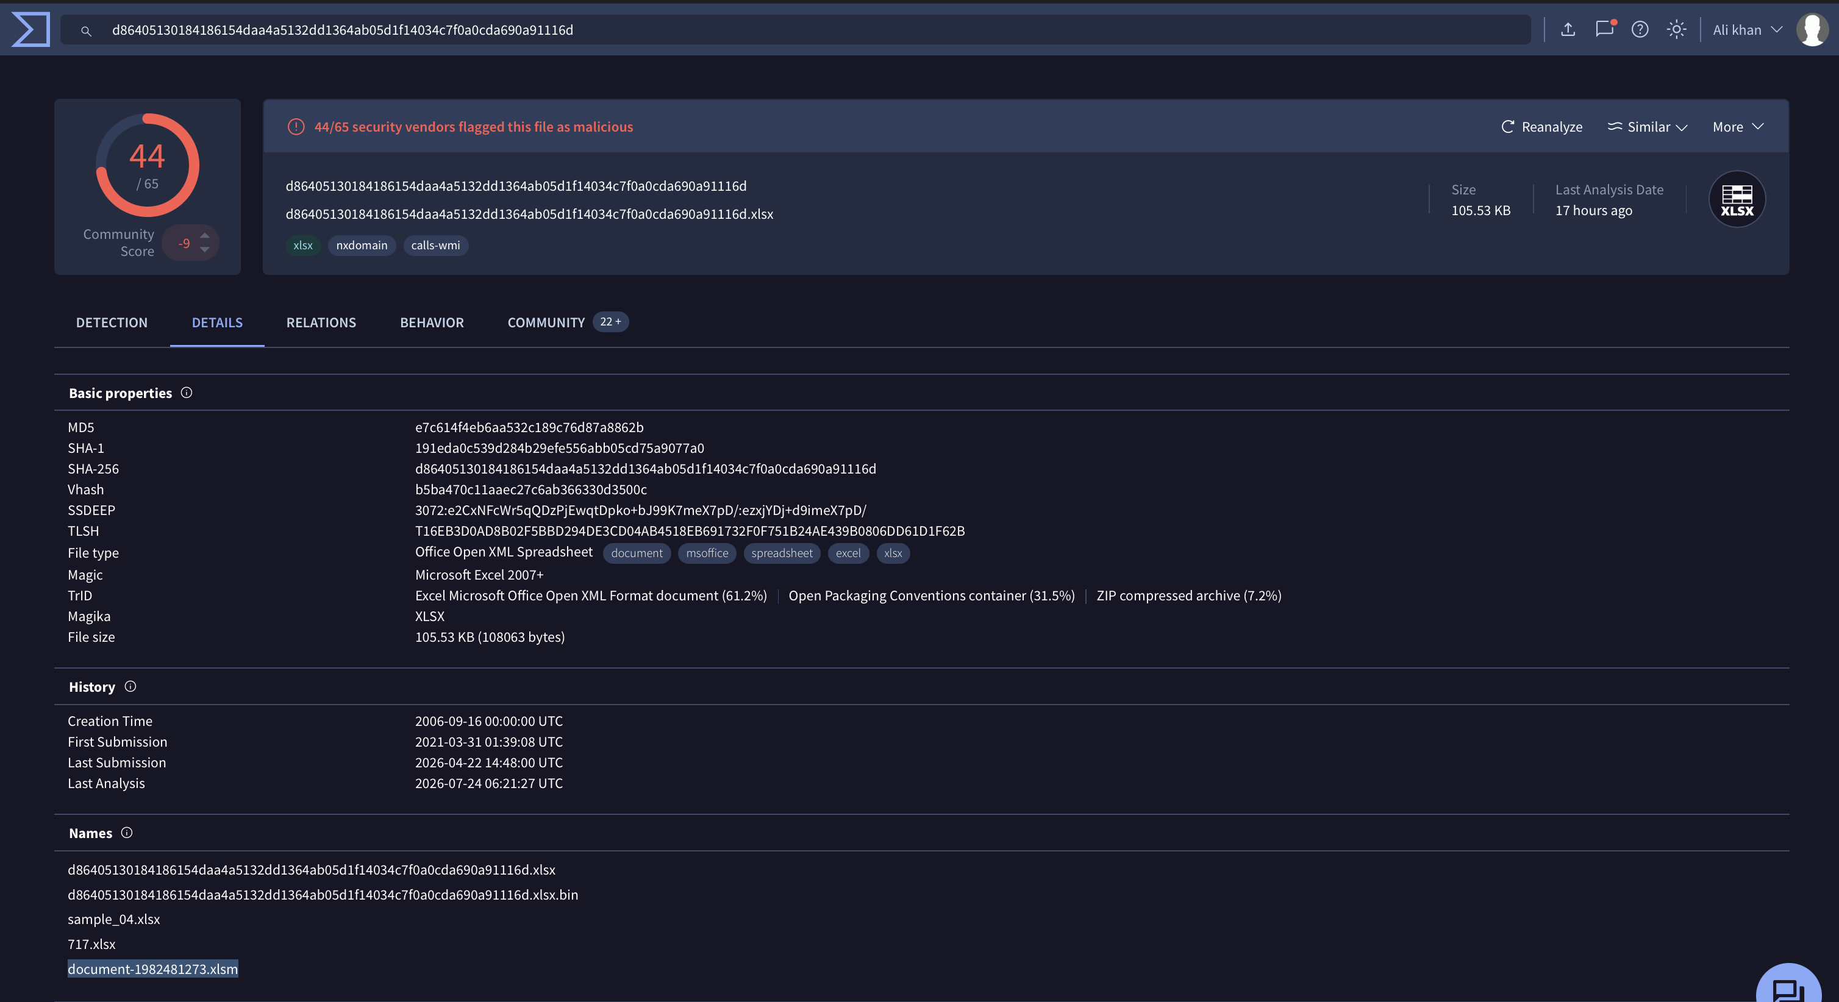
VirusTotal — Details tab showing the Names section with the associated filename highlighted.
Answer: document-1982481273.xlsm

Q2 — Can you identify the filename of the GIF file that was deployed?
Approach:
On Triage Sandbox, open the Behavior tab and check the Files Dropped section. The malicious Excel macro reaches out and drops a GIF-named payload into the IE INetCache folder, disguised as an image to avoid raising suspicion.
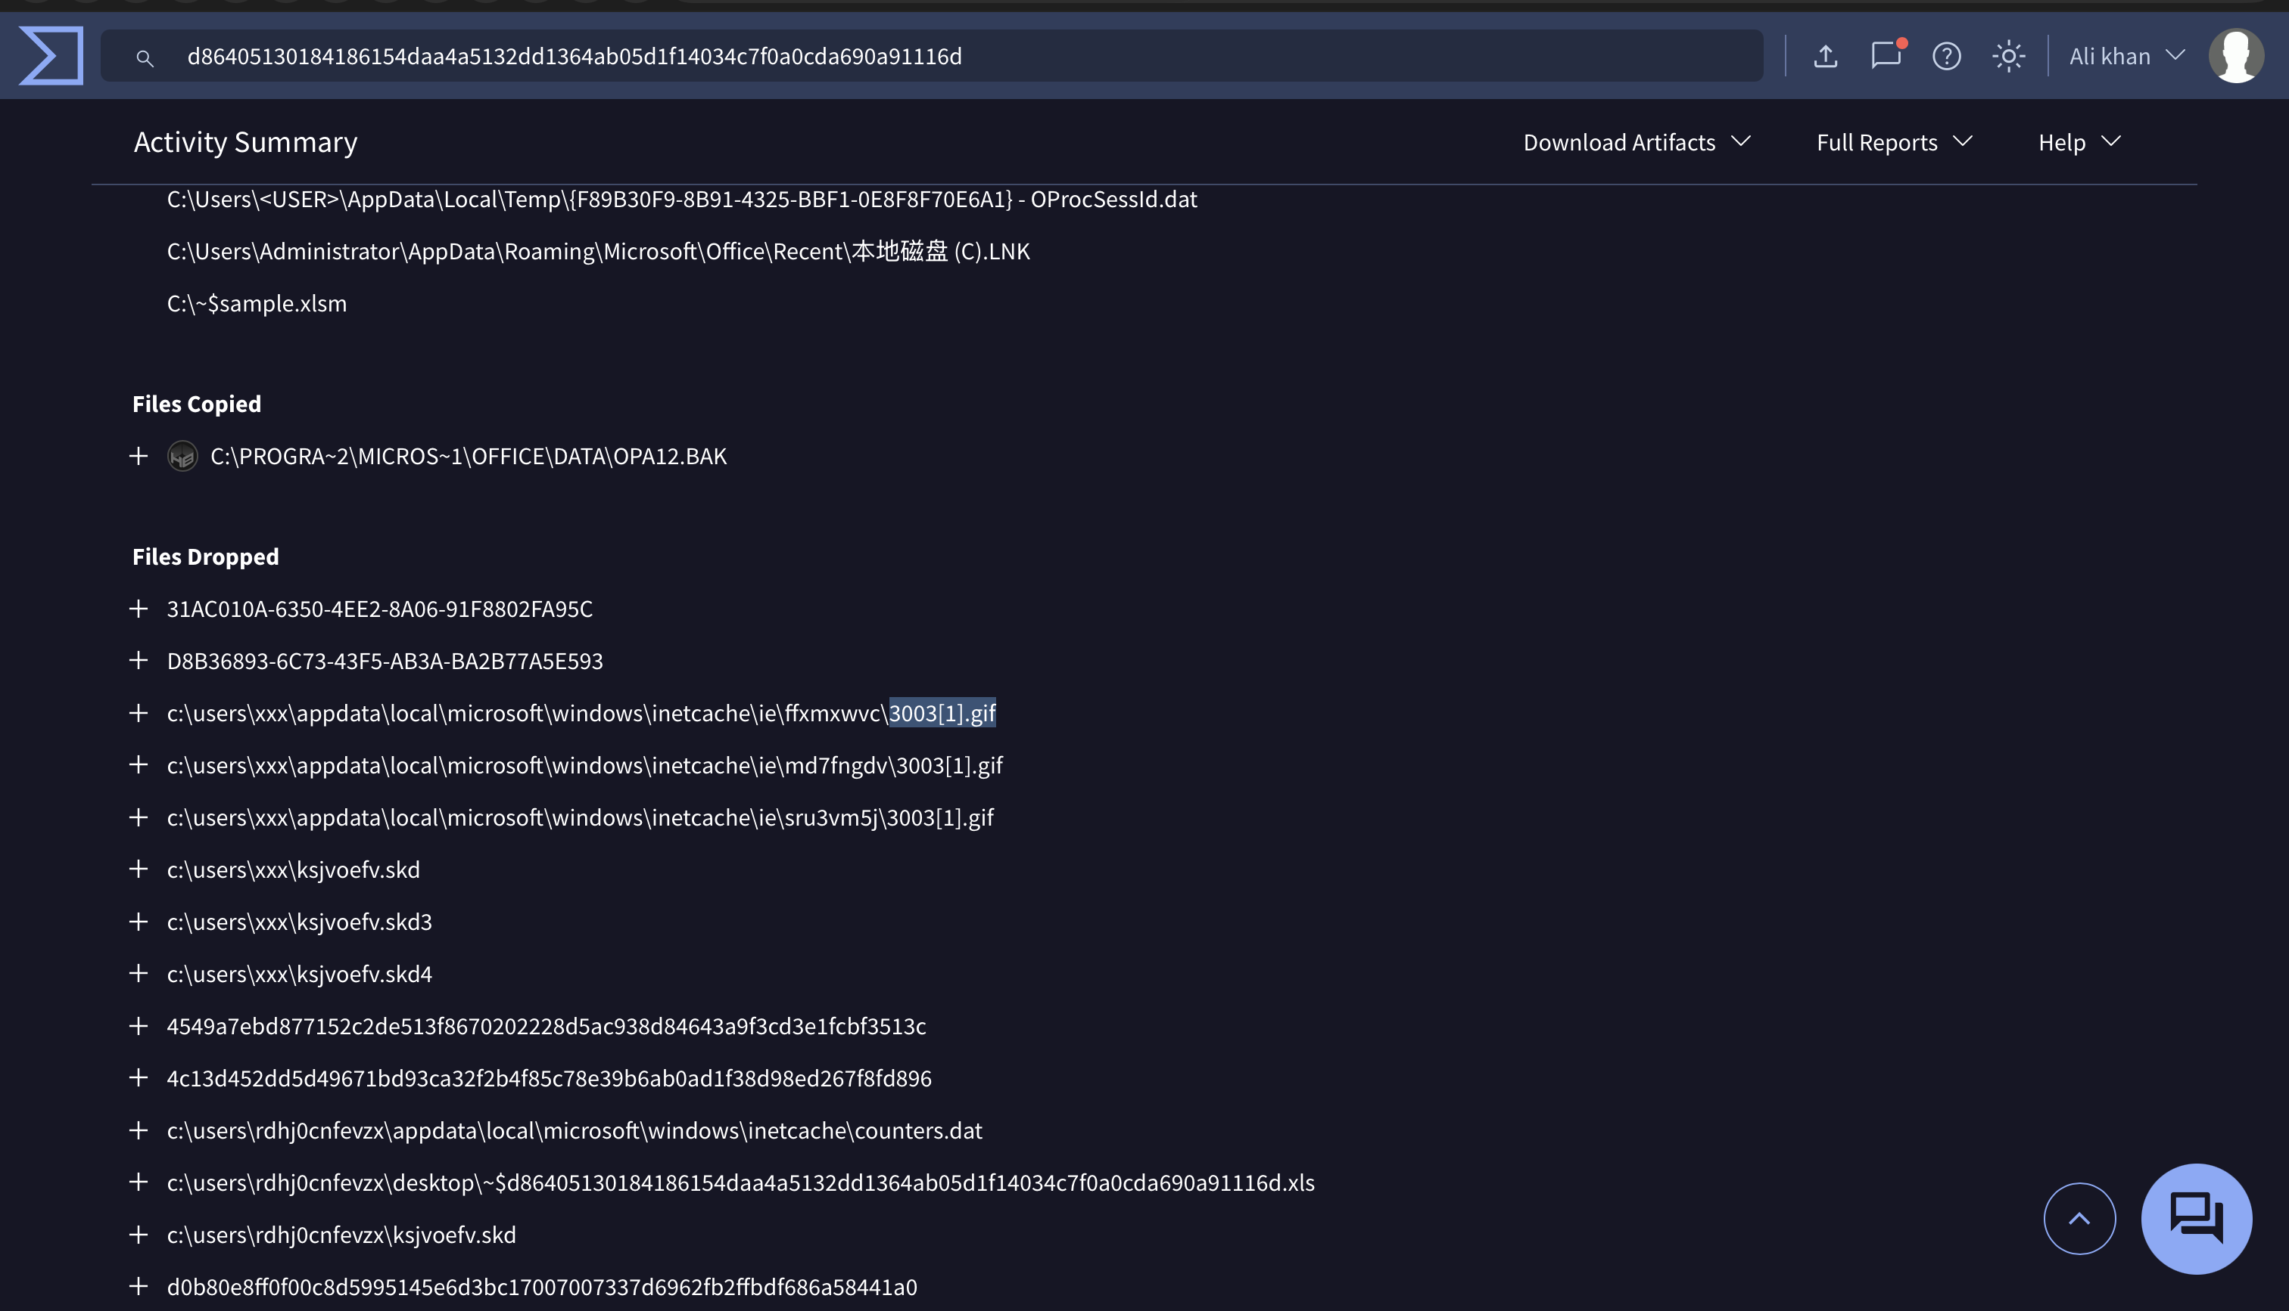
Triage Sandbox — Behavior tab, Files Dropped list showing 3003[1].gif dropped in the INetCache path.
Answer: 3003.gif

Q3 — How many domains does the malware look to download the additional payload file in Q2?
Approach:
Still in the Behavior tab, open the HTTP Requests section. Each GET request targeting /ds/3003.gif represents an attempt to fetch the payload from a different domain. Counting the unique domains making that request (not counting retries to the same domain) gives the total.
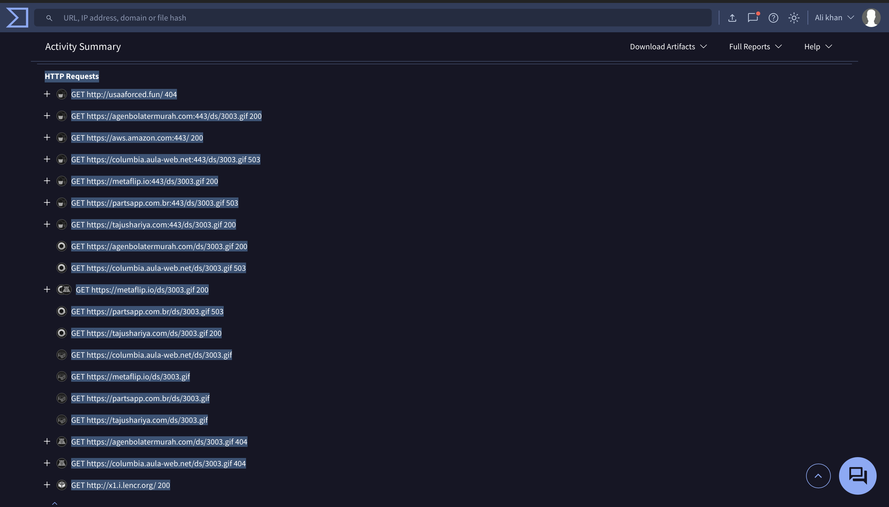
Triage Sandbox — Behavior tab, HTTP Requests showing GET requests to /ds/3003.gif across multiple domains.
Answer: 5

Q4 — From the domains mentioned in Q3, a DNS registrar was predominantly used by the threat actor. Can you specify the Registrar Inc?
Approach:
Cross-referencing VirusTotal's Contacted Domains table for each of the five malicious domains from Q3 against their WHOIS records showed that two of them — agenbolatermurah.com and tajushariya.com — were both registered through NameCheap, Inc. Since NameCheap was the registrar that repeated across multiple malicious domains, it was identified as the predominant registrar.
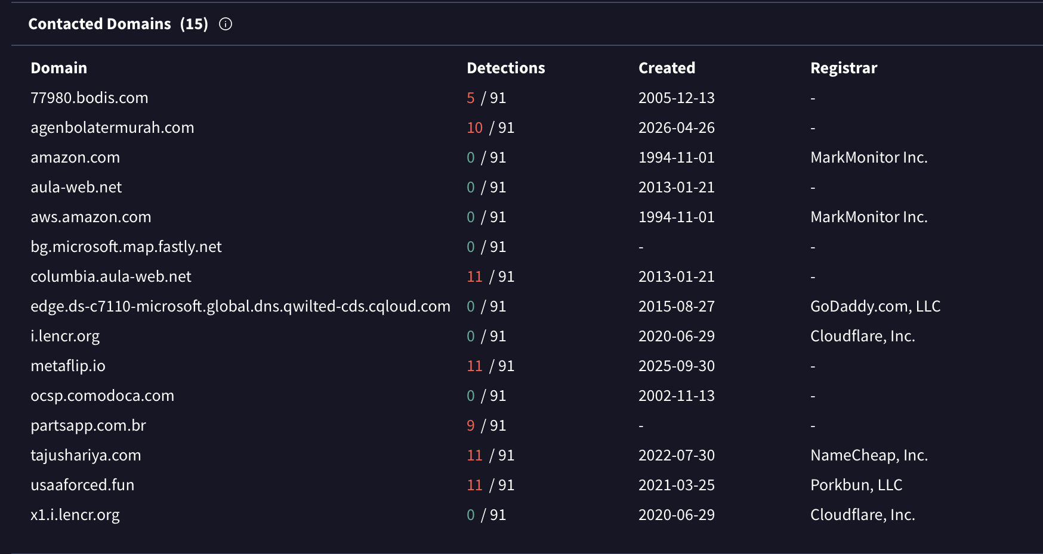
VirusTotal Contacted Domains table (help-center reference) — agenbolatermurah.com and tajushariya.com both list NameCheap, Inc. as the registrar.
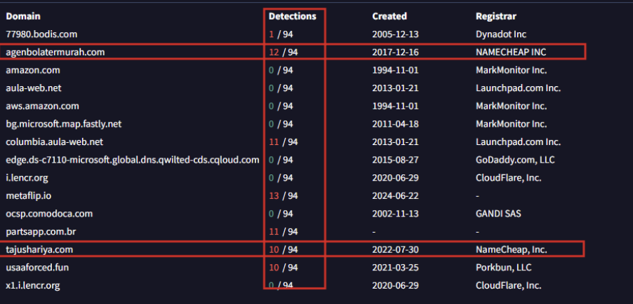
Contacted Domains table from own lookup, most registrar fields showing as blank ('-').
Note — why my own WHOIS lookup didn't show NameCheap:
I couldn't find NameCheap in my own WHOIS lookup because the domain had since expired and been re-registered by DropCatch, a domain drop-catching service. Since WHOIS only shows current registration data, the original registrar from the time of the actual malicious activity (2017) was replaced by the new one (2026) in later lookups.
Answer: Namecheap

Q5 — Could you specify the threat actor linked to the sample provided?
Approach:
Checked the Community tab on the sample's VirusTotal page. Community-submitted comments and crowdsourced context often carry attribution notes from other analysts who have already researched the sample. A comment directly named the threat actor group tied to this IcedID sample.
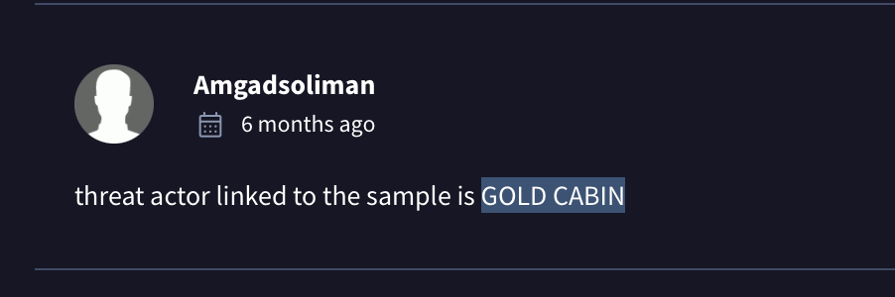
VirusTotal — Community tab comment naming the threat actor as GOLD CABIN.
Answer: GOLD CABIN

Q6 — In the Execution phase, what function does the malware employ to fetch extra payloads onto the system?
Approach:
Searched the sample hash in Triage Sandbox and opened the Static analysis tab, then checked the Malware Config section. The extracted XLM macro source shows repeated CALL statements invoking a specific Windows API function through URLMon to download the GIF payload from each malicious domain onto disk.
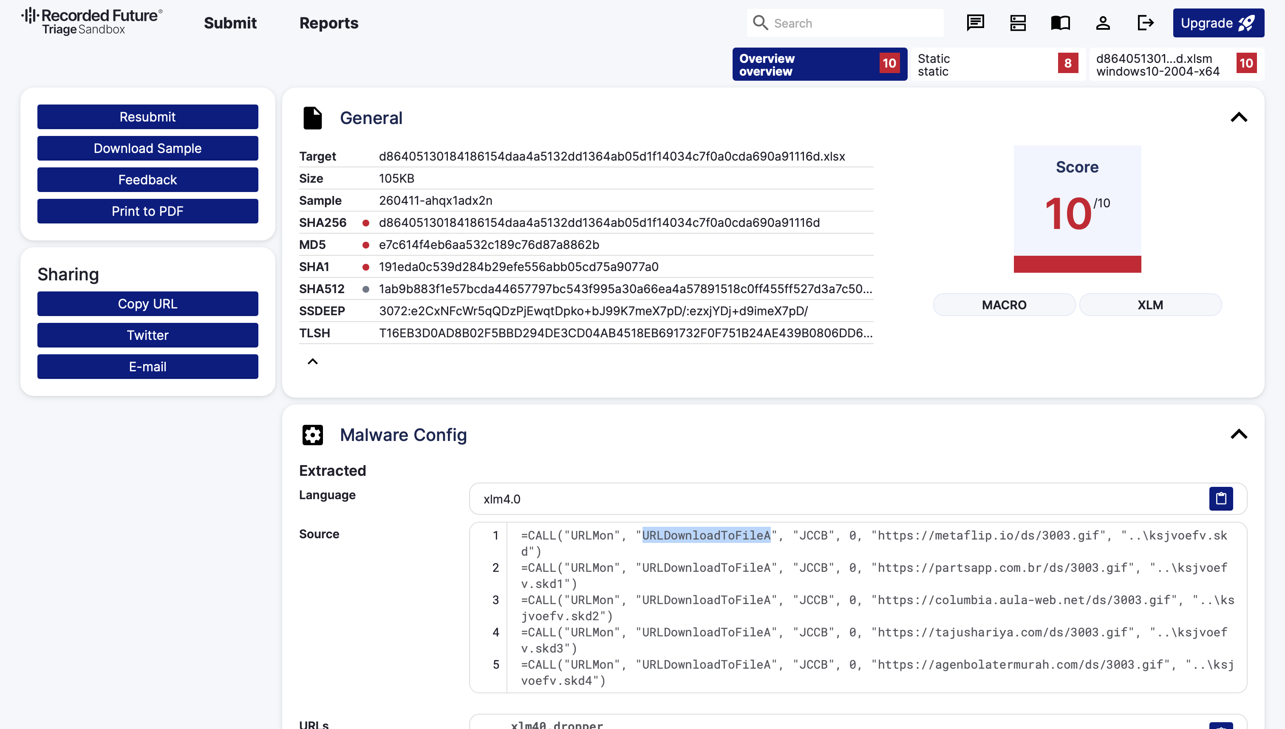
Triage Sandbox — Static tab, Malware Config showing extracted XLM macro calls to URLDownloadToFileA for each payload domain.
Answer: URLDownloadToFileA

Summary
The sample (document-1982481273.xlsm) is a malicious Excel 4.0 macro (XLM) document that, on execution, calls URLDownloadToFileA via URLMon across five hardcoded domains to fetch a payload disguised as 3003.gif into the IE INetCache directory. Two of the five delivery domains (agenbolatermurah.com and tajushariya.com) were originally registered through NameCheap, Inc., indicating a registrar preference by the threat actor at the time of the campaign, though later WHOIS lookups reflect a different registrar due to domain expiry and drop-catch re-registration. Community attribution on VirusTotal links this IcedID sample to the threat actor group GOLD CABIN.

